Prior Knowledge needed:
- EJ Job Number
- Text file of barcodes (.txt)

To Batch Unload:

Open EasyJob

Select Projects In top navbar, and then BatchLoad

This will open up a new screen

In this new window, go to the top right and click Import
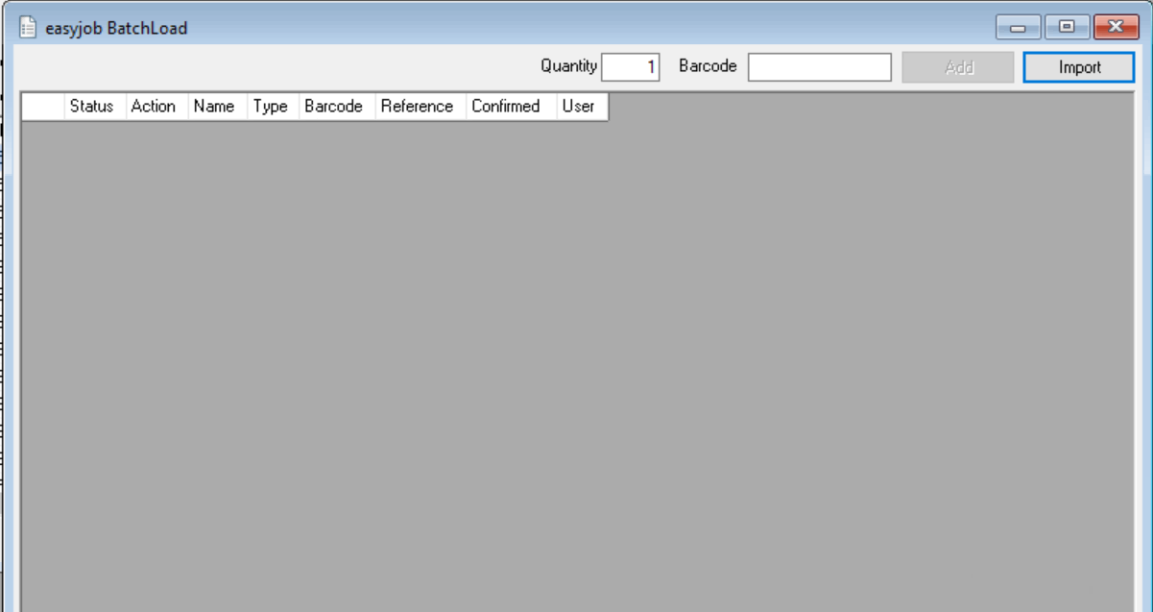

Make sure "Project / Job" is selected and then click "OK"
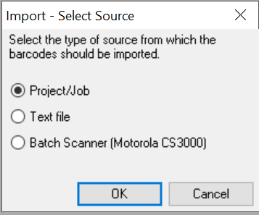

Next in the job search popup - search for your job by number / name and Click OK
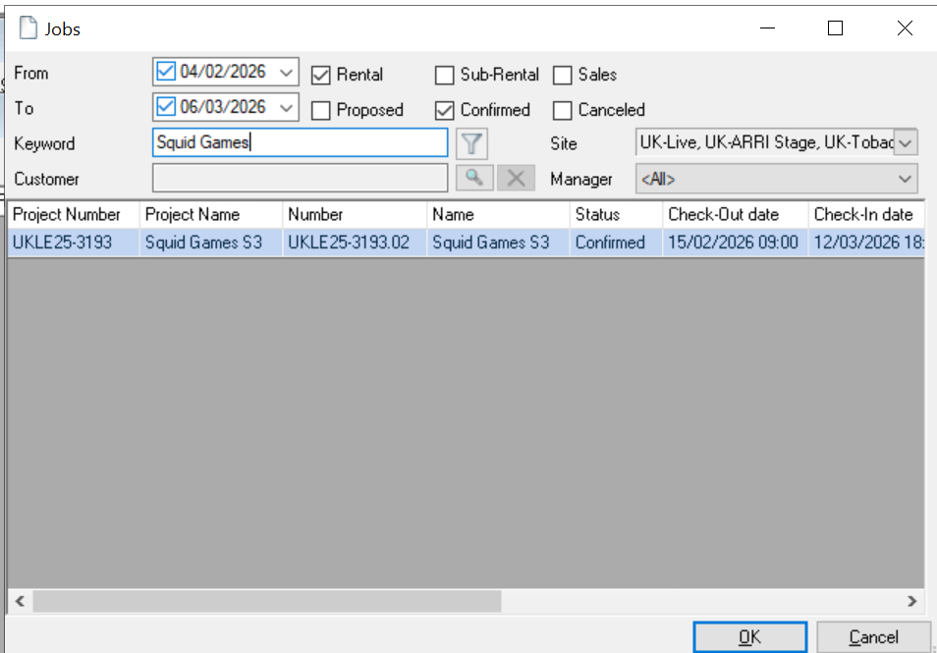

Either:
A)
Select the items you want to unload by ticking the first box of them (item’s checkbox) and clicking OK
{INSERT PHOTO of item checklist}

This should add those items to the batch load page.
{INSERT PHOTO of items added to unload page}

Check through this list and make sure there is no errors.
Also check that the Action is stated as ‘Unload’
Click “Confirm All” – this will add a tick in the checkbox for each item.
Click “Execute” and in the popup asking to Start the process press “Ok”
You have now successfully batch unloaded items from a text file off of a job in easyjob.

Or B):

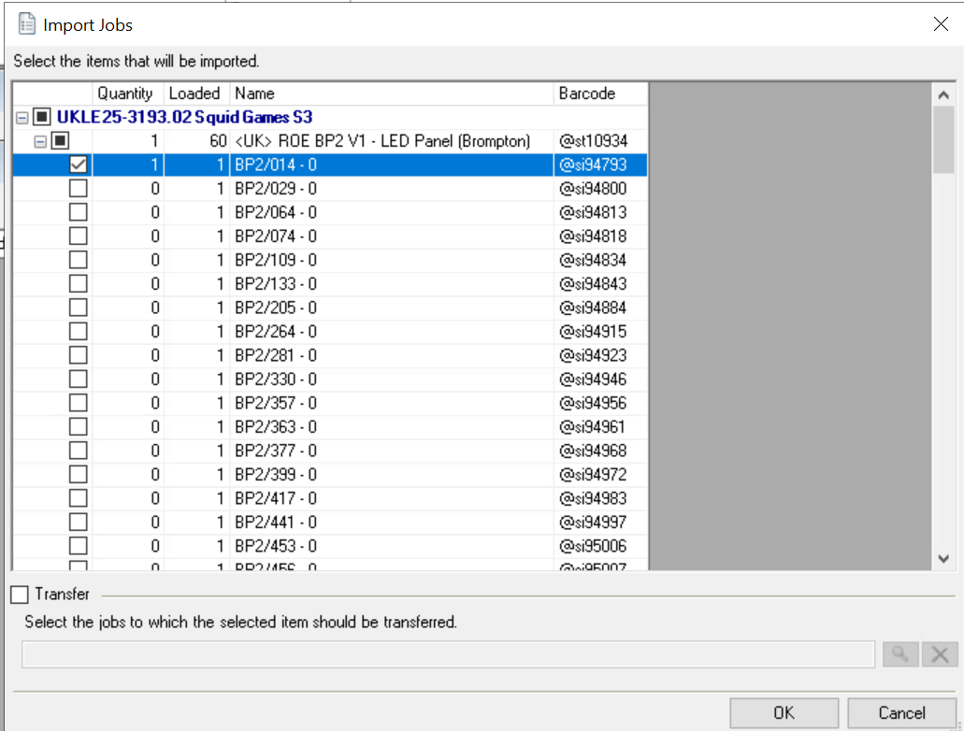

This should add that single item to the batch load page.
{{INSERT PHOTO of 1 item on batchunload page}

To add your new barcodes to add, click the “Import” button again, this time selecting the “Text File” and pressing OK

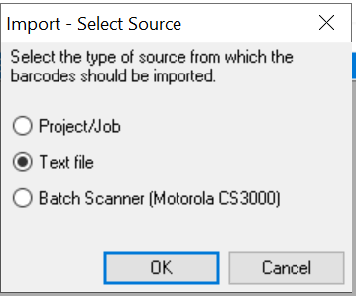

It will now bring up a file explorer window for you to find your text file of barcodes
Navigate to your computer by: This PC -> Local Disk (C: On ***) -> Users -> (*YOUR USERNAME*) -> OneDrive – NEP Group, Inc) From here you can find your text file of barcodes.

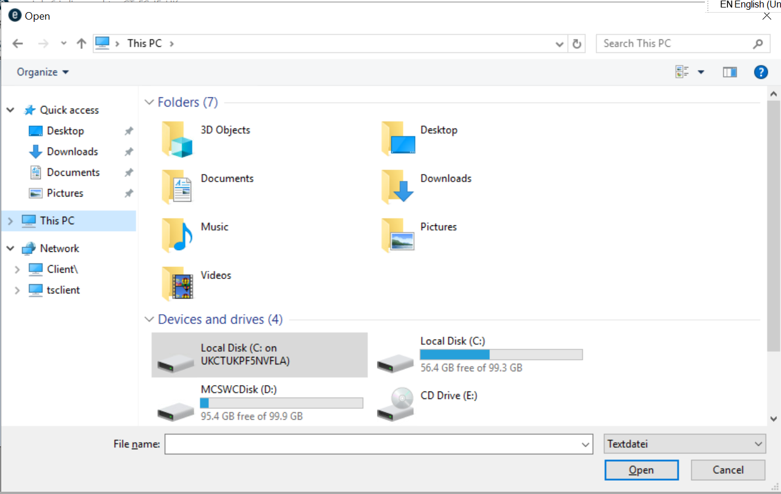
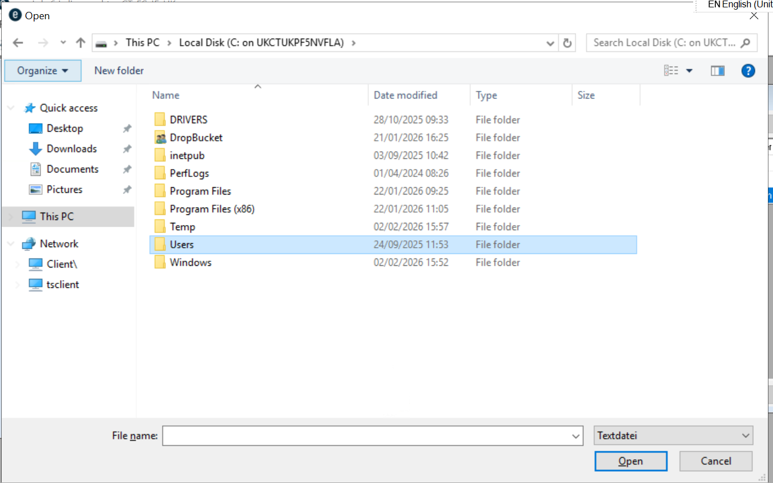
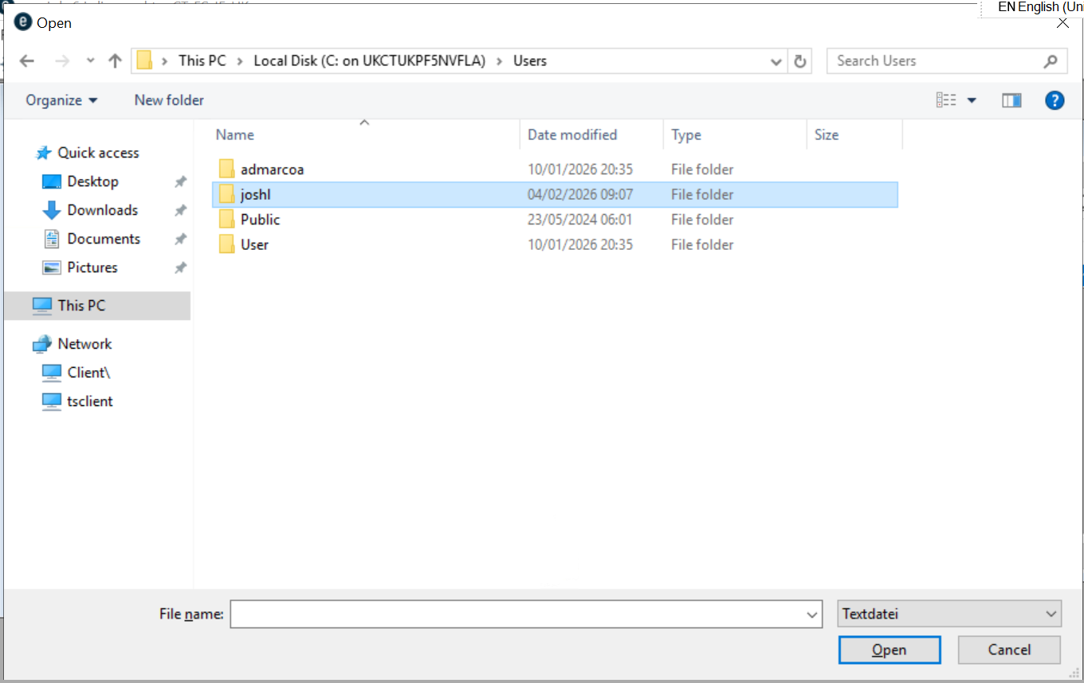
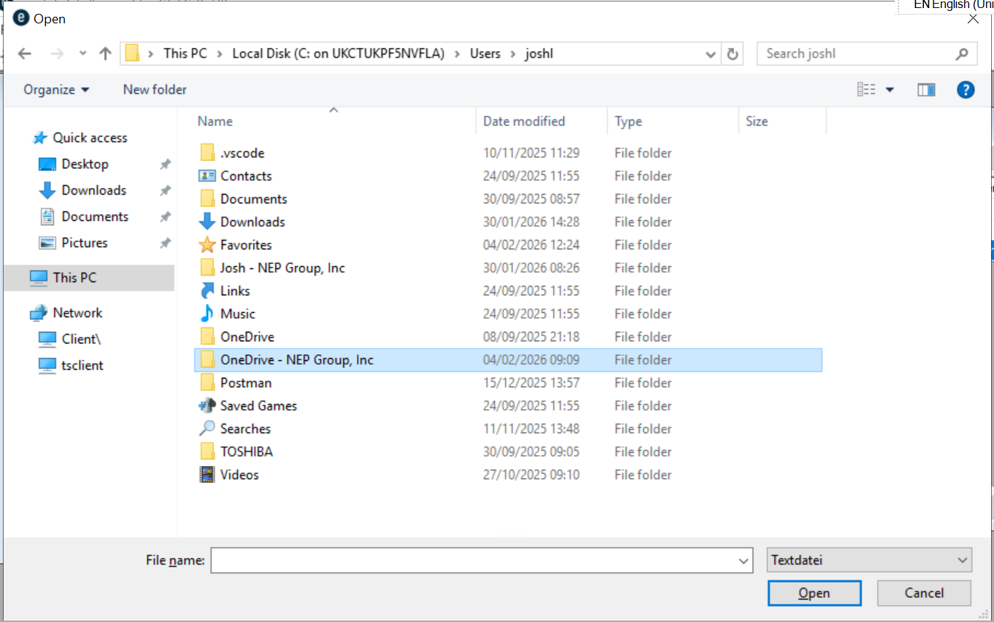

Now search for your file at press “Open”
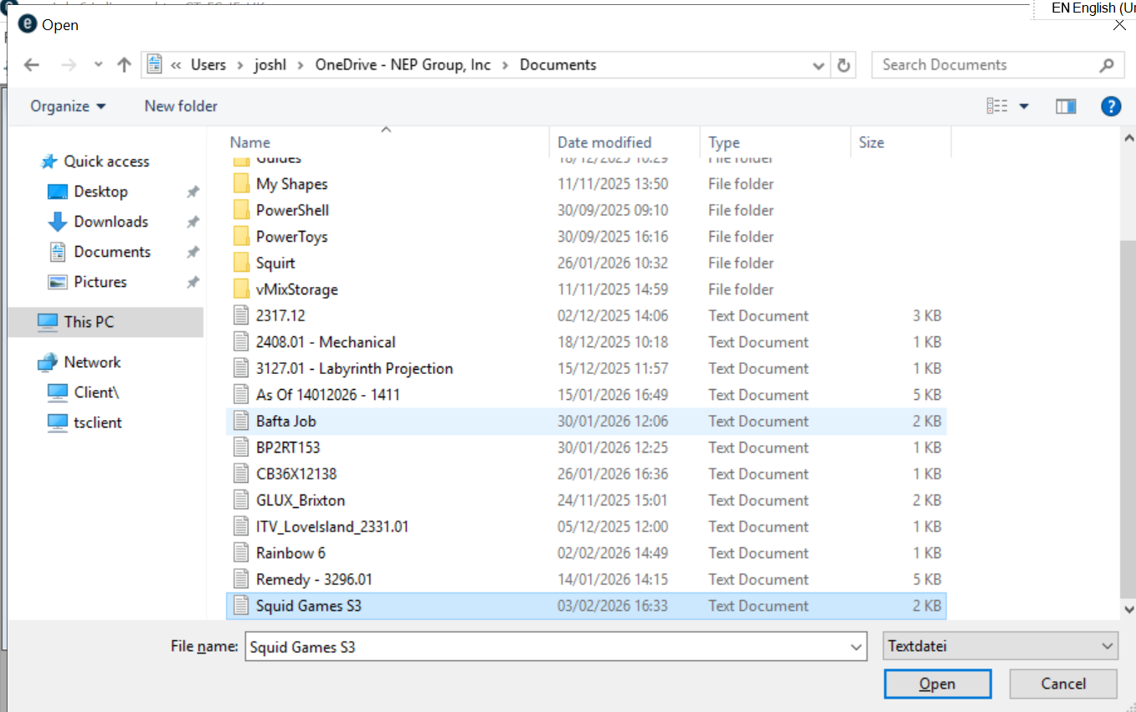

This should add your new barcodes to the batchload screen.
{INSERT PHOTO batchunload page}

Check through this list and make sure there is no errors.
Also check that the Action is stated as ‘Load’
Click “Confirm All” – this will add a tick in the checkbox for each item.
Click “Execute” and in the popup asking to Start the process press “Ok”

